Introduction to SIEM - Lab Report

Date: 25/05/2026
Difficulty: Easy
Category: Defensive Security (SOC)
Platform: TryHackMe

Overview

This lab looks at the SIEM (Security Information and Event Management) solution which are used by SOC analysts to make their job easier and have a centralized storage of logs which can be viewed and investigated when suspicious activity is found via detection rules which are set on the SIEM. The practical aspect of this lab shows how an alert can be investigated and actioned using SIEM.

2. Toolset Used

Tool | Purpose / Function
SIEM solution | Central security hub that automatically collects and analyses activity data from across an entire network to identify, alert and log cyber threats

3. What I did

SIEM stands for Security Information and Event Management System and is a core security solution for a SOC analyst. In a network with various devices such as the diagram below from TryHackMe, it shows both Linux and Windows endpoints, a web server and a data server.

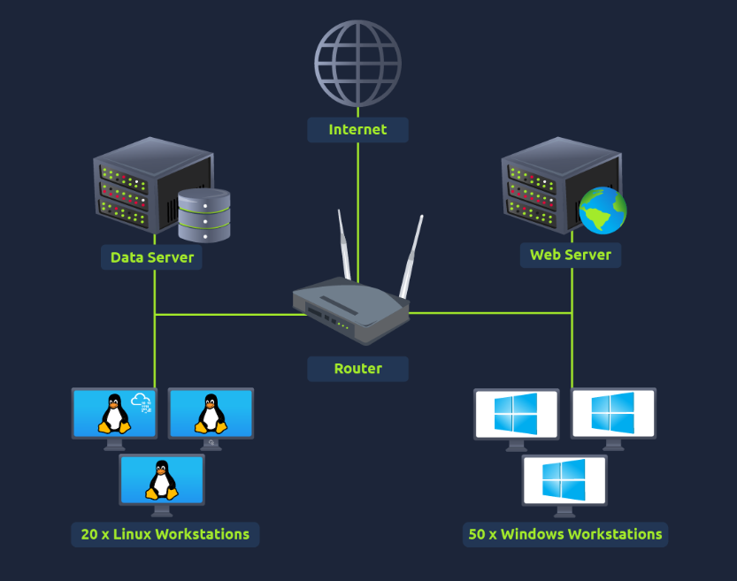

These devices contain logs of activities that happen within them which can help when troubleshooting or identifying malicious activity. There are 2 log categories – Host-Centric and Network-Centric.

Host-Centric: Events that occur within or related to the host such as a user accessing a file, attempted authentication, PowerShell execution or execution of a process.

Network-Centric: Events that occur when hosts communicate with each other or access the internet to visit a website such as SSH connections, web traffic, a file being accessed via FTP or a user accessing the company’s resources through a VPN.

However, there are numerous challenges with log sources such as large amounts of events from various log sources if the network has multiple devices, limited context and analysis as individual logs don’t always tell the whole story of an incident and there can be loads of logs to go through so analysing them all can take a long time.

The solution to these problems is SIEM as it is the security solution which collects logs from various types of log sources, uses a consistent format, correlates them and detects malicious activity using detection rules.

Features of SIEM:

- Centralized log collection – it collects logs from all sources and stores them in one place for ease of access when analysing the logs.
- Normalization of logs – as raw logs come in different formats and sizes, SIEM formats all the logs into the same consistent format which makes them easier to read.
- Correlation of logs – as individual logs are not very useful, SIEM correlates logs of different sources and identifies relationships between them. This helps find malicious activity by analysing the patterns.
- Real-time alerting – SIEM detects malicious activity based on the rules set. Many rules are set on a SIEM by default, but analysts can make new rules if they wish. When the conditions for these detection rules are met then alerts are triggered and analysts are notified so they can investigate them.
- Dashboards and Reporting – In the dashboard you can find information such as notifications, health alert, rules triggered, alerts and events ingested count. These dashboards help analysts have an overview of the system which can be used in the reporting stages.

Windows logs: Windows events can be viewed through event viewer which assigns a unique ID to each type of log activity.

Linux logs: Linux stores all related logs such as events, errors and warnings. These logs are stored within /var/log.

Each SIEM solution has its own way to ingest (add) the logs such as either port-forwarding, manual upload or agent/forwarding.

Some examples of detection rules:

- Multiple failed login attempts
- Successful login after multiple login attempts
- USB being plugged in

Once an alert is triggered, the events are investigated by an analyst, and they decide if it is a true or false positive. If it is a true positive, then further investigation is performed but if it is a false positive then the rule may be altered to prevent future false positives.

Practical Lab:

This practical provides a sample SIEM solution with a dashboard which simulates alerts. The alert is highlighted in red and needs to be investigated.

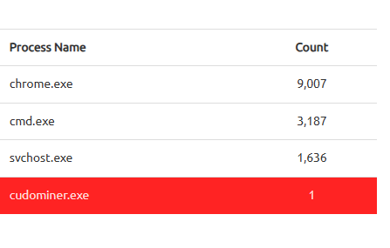

After clicking on the alert, I am able to view all the logs and see that the Hostname is HR_02 and the username is a user named Chris.

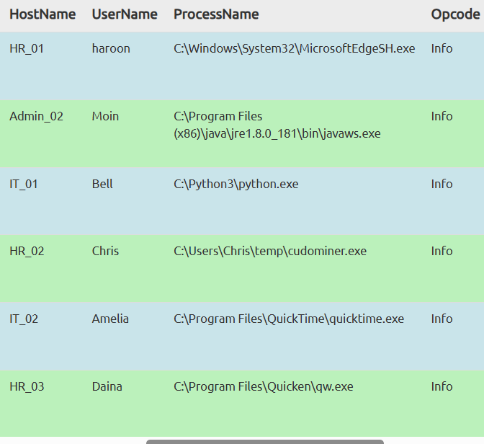

The rule that detected it is shown below and the *miner* part detects it as the file is named cudominer.

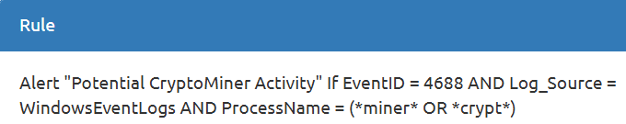

After review, I decided that this alert was a true positive so the host was isolated to prevent further damage.

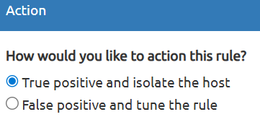

4. What I’ve learned

- How SIEM solutions help SOC analysts
- SIEM solutions help mitigate the challenges of log sources
- Hands on experience of finding, investigating and acting on an alert on a SIEM system
- Features of SIEM
- Detection rules
- Where to find logs on Windows and Linux

